Halifax Network Expansion

# TAKS 1 – Network development.

* Network diagram:

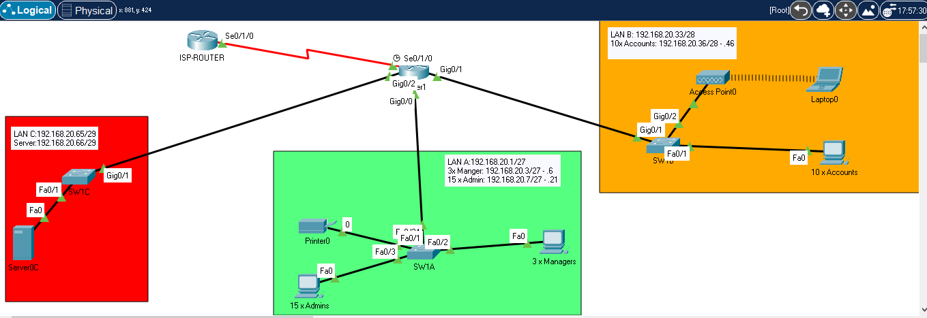

* Network IP address configuration table:

|  |  |  |  |  |
| --- | --- | --- | --- | --- |
| **NETWOR REF** | **Device** | **Interface** | **IP Address or Network** | **Default Gateway** |
|  | ISP Router | S0/1/0 | 192.168.20.77/30 | - |
| Router 1 | G0/0 | A  191.168.20.1/27 | 191.168.20.1 |
| G0/1 | B  192.168.20.33/28 | 191.168.20.1 |
| G0/2 | C  192.168.20.65/29 | 191.168.20.1 |
| S0/1/0 | 192.168.20.78/30 | - |
| **"A/27"** | Printer | NIC | 192.168.20.3 | 191.168.20.1 |
| **"A/27"** | SW1A | NIC | 192.168.20.2 | 191.168.20.1 |
| **"A/27"** | Manager 1 | NIC | 192.168.20.4 | 191.168.20.1 |
| **"A/27"** | Manager 2 | NIC | 192.168.20.5 | 191.168.20.1 |
| **"A/27"** | Manager 3 | NIC | 192.168.20.6 | 191.168.20.1 |
| **"A/27"** | Admin 1 | NIC | 192.168.20.7 | 191.168.20.1 |
| **"A/27"** | Admin 2 | NIC | 192.168.20.8 | 191.168.20.1 |
| **"A/27"** | Admin 3 | NIC | 192.168.20.9 | 191.168.20.1 |
| **"A/27"** | Admin 4 | NIC | 192.168.20.10 | 191.168.20.1 |
| **"A/27"** | Admin 5 | NIC | 192.168.20.11 | 191.168.20.1 |
| **"A/27"** | Admin 6 | NIC | 192.168.20.12 | 191.168.20.1 |
| **"A/27"** | Admin 7 | NIC | 192.168.20.13 | 191.168.20.1 |
| **"A/27"** | Admin 8 | NIC | 192.168.20.14 | 191.168.20.1 |
| **"A/27"** | Admin 9 | NIC | 192.168.20.15 | 191.168.20.1 |
| **"A/27"** | Admin 10 | NIC | 192.168.20.16 | 191.168.20.1 |
| **"A/27"** | Admin 11 | NIC | 192.168.20.17 | 191.168.20.1 |
| **"A/27"** | Admin 12 | NIC | 192.168.20.18 | 191.168.20.1 |
| **"A/27"** | Admin 13 | NIC | 192.168.20.19 | 191.168.20.1 |
| **"A/27"** | Admin 14 | NIC | 192.168.20.20 | 191.168.20.1 |
| **"A/27"** | Admin 15 | NIC | 192.168.20.21 | 191.168.20.1 |
| **"B/28"** | Laptop | NIC | 192.168.20.35 | 191.168.20.33 |
| **"B/28"** | SW1B | NIC | 192.168.20.34 | 191.168.20.33 |
| **"B/28"** | Accounts 1 | NIC | 192.168.20.36 | 191.168.20.33 |
| **"B/28"** | Accounts 2 | NIC | 192.168.20.37 | 191.168.20.33 |
| **"B/28"** | Accounts 3 | NIC | 192.168.20.38 | 191.168.20.33 |
| **"B/28"** | Accounts 4 | NIC | 192.168.20.39 | 191.168.20.33 |
| **"B/28"** | Accounts 5 | NIC | 192.168.20.40 | 191.168.20.33 |
| **"B/28"** | Accounts 6 | NIC | 192.168.20.41 | 191.168.20.33 |
| **"B/28"** | Accounts 7 | NIC | 192.168.20.42 | 191.168.20.33 |
| **"B/28"** | Accounts 8 | NIC | 192.168.20.43 | 191.168.20.33 |
| **"B/28"** | Accounts 9 | NIC | 192.168.20.44 | 191.168.20.33 |
| **"B/28"** | Accounts 10 | NIC | 192.168.20.45 | 191.168.20.33 |
| **"C/29"** | SW1C | NIC | 192.168.20.67 | 191.168.20.65 |
| **"C/29"** | Server 0C | NIC | 192.168.20.66 | 191.168.20.65 |

Network ping screenshots:

1-Admin computer to the Server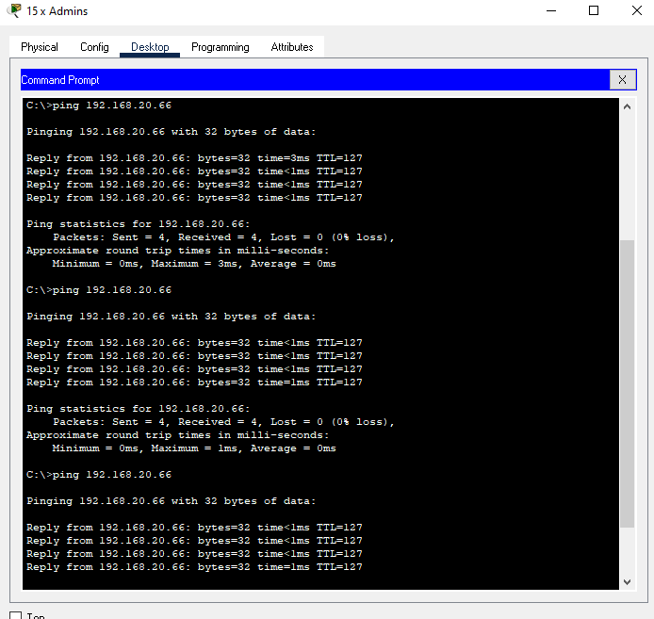

2-Management computer to accountants computer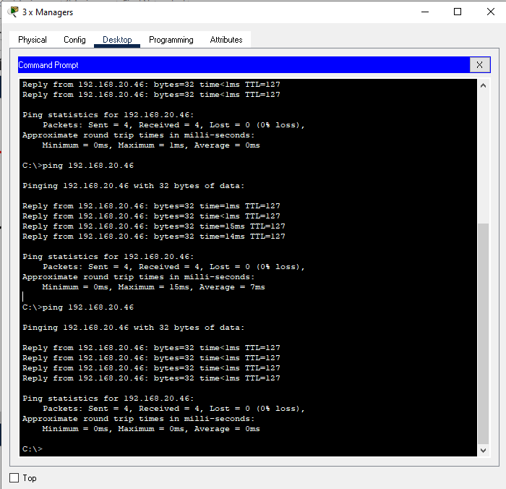

3-Ping result from Wireless laptop to ISP

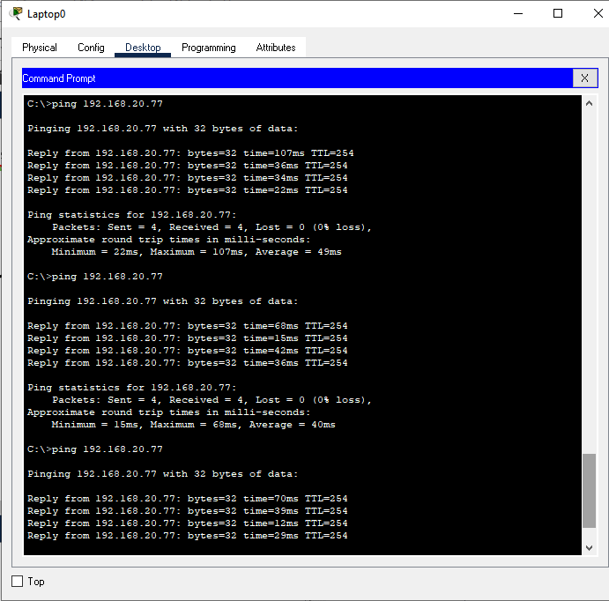

4-Ping result from Admin to ISP

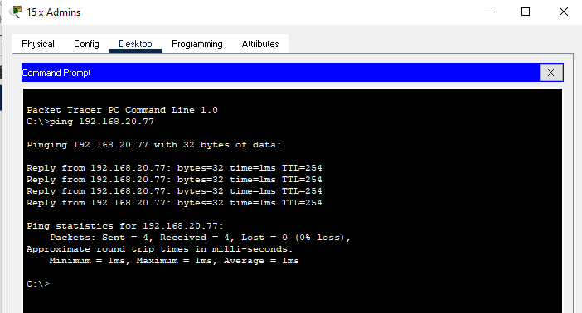

TASK2

DHCP

Dynamic Host Configuration Protocol (DHCP) is a client/server protocol framework that automatically provides an Internet Protocol (IP) host with its IP address and other related configuration information such as the subnet mask and default gateway to device connected to the local network. (R Droms, 1997, Network Working Group)

The use of DHCP in networking allows devices to connect to a network. In the previous network, IP addresses were assigned manually, in networking this process is referred to as a static procedure which opens room to human error and misses calculation when assigning the IP address in the network for every device, thus requires time to administrate.

The IP addresses assigned manually limit new devices to access the network if all IP address available are already assigned or if a new workstation is moved between two different networks, the IP address of the machine must be manually redeemed and assign to it a new IP address of the current network.

We can see that using the static procedure of assigning IP address is quite mechanical and not 100% reliable. This is where DHCP comes to help, since this protocol is dynamic, the whole procedure is smoother and accurate.

We can simply put DHCP as a pool of IP address related to a local network when a device accesses the network and pass the security checks, the protocol will assign an IP address, subnet mask and default-gateway by leasing it from the pull of IP address available at that time.

If a device ends the connection with the network, the IP address previously leased, is back restored into the pull ready to be used. This procedure is automatic, meaning its reliable after the configuration is successful.

Some important temps in DHCP.

Scope: the range of IP addresses.

Address Leases: assessment and leasing of IP addresses

Reservation: If the network ever changes, the device will have the same IP address in the DHCP server.

Option: DHCP server shares information to allow devices to access other parts or devices of the network for examples the subnet or default gateway address, DNS servers, and time servers Network Time Protocol (NTP).

In DHCP, this process is formalized with the common designation Discover, Offer, Request, Acknowledge (DORA). (Odom, Wilkins 2013)

Experimental results demonstrate scalability

of the approach such that large-scale network scenarios

can be handed (Hubballi, Tripathi 2016)

Default-gateway

A gateway delaine the perimeter of a network or sub-network, it is the local network IP address and every device in that specific network must have assigned a default gateway to reference the router in the network when the destination of a package is unknown in the network pull, meaning the router must send the package outside the network and only a router can perform such task.

If an IP address is pinged and this is not referenced in the local area network this will inform the router to perform the request is attempting to connect to another network using the IP address provided, since a router finds the best possible path to deliver the package if this is not found, the response would be that “the router IP address: destination host is unreachable”. Else the router will message a successful connection.

Reference

<https://tools.ietf.org/html/rfc2131> (D. Ron 1997)

https://www.pearsonitcertification.com/store/ccna-routing-and-switching-200-120-network-simulator-9780789750884 (1st edition person) ( Wendell Odom, Sean Wilkins 2013)

<https://www.sciencedirect.com/science/article/pii/S0167404816301262> (Computers & Security, Volume 65, March 2017, Pages 387-404 Computers & Security Neminath Hubballi, Nikhil Tripathi 2016)